

**MATHEMATICS DEPARTMENT**

**MATHEMATICAL METHODS YEAR 12 – TEST 1**

DATE: 2nd December 2015 Name:_________________________

**Reading Time:** 3 minutes

**SECTION ONE: CALCULATOR FREE**

WORKING TIME: Maximum 25 minutes

TOTAL: 24 marks

EQUIPMENT: pens, pencils, pencil sharpener, highlighter, eraser, ruler, formula sheet (provided)

**SECTION TWO: CALCULATOR ASSUMED**

WORKING TIME: Minimum 25 minutes

TOTAL: 26 marks

EQUIPMENT: pens, pencils, pencil sharpener, highlighter, eraser, ruler, drawing instruments, templates, up to 3 calculators, formula sheet (provided) one A4 page of notes (one side only)

|  |  |  |  |  |  |
| --- | --- | --- | --- | --- | --- |
| **Question** | **Marks available** | **Marks awarded** | **Question** | **Marks available** | **Marks awarded** |
| 1 | 6 |  | 5 | 4 |  |
| 2 | 4 |  | 6 | 7 |  |
| 3 | 7 |  | 7 | 8 |  |
| 4 | 7 |  | 8 | 7 |  |
|  |  |  |  |  |  |
| **Sect 1 Total** | **24** |  | **Sect 2 Total** | **26** |  |
|  |  |  | **TOTAL** | **50** |  |

**Question 1 (6 marks)**

Find the antiderivative of each of the following, giving all answers with positive indices.

a)  (3 marks)

(b)  (3 marks)

**Question 2 (4 marks)**

Let.

The derivative of  can be written in the form .

Determine the value of *a*, *b* and *c.*

**Question 3 (7 marks)**

Let A, B, C, D, E, F and G be points on the graph of a continuous function .

The table below shows the information about the sign of ,  and at these points.

|  |  |  |  |  |  |  |  |
| --- | --- | --- | --- | --- | --- | --- | --- |
| **Point** | **A** | **B** | **C** | **D** | **E** | **F** | **G** |
|  | -4 | -3 | -1 | 0 | 1 | 2 | 4 |
|  | + | 0 | - | 0 | + | + | + |
|  | - | - | 0 | + | + | 0 | + |
|  | + | + | + | 0 | - | 0 | + |

There are no other points at which ,  or are equal to zero.

(a) Which point is a local minimum? (1 mark)

(b) Describe the nature of the graph at point F. (2 marks)

(c) Sketch the function on the axes below. (4 marks)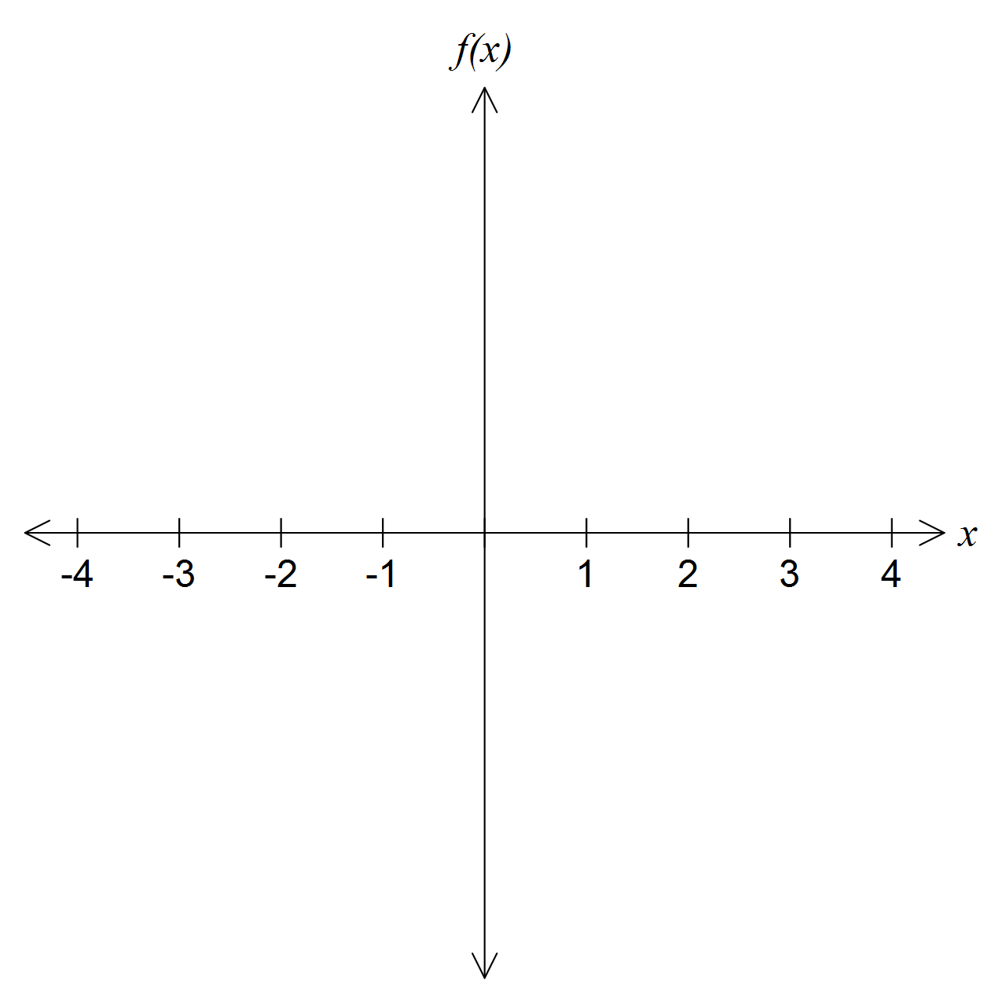

**Question 4 (7 marks)**

Consider the function .

A sketch of part of the graph of *h* is given below.

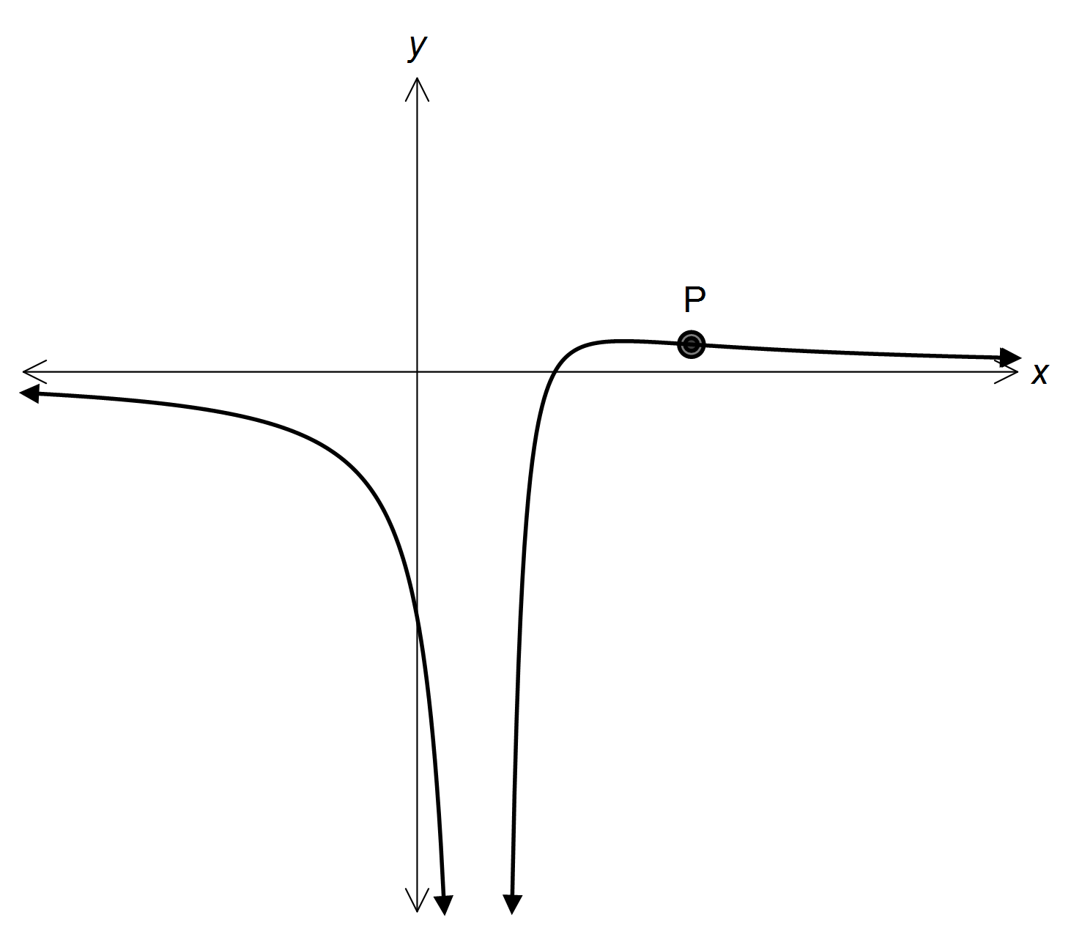

The point P is a point of inflexion.



(a) Find *h′(x),* writing your answer in the form

where *a* and *n* are constants to be determined. (4 marks)

**Question 4 continued on next page…**

**Question 4 continued…**

(b) Given that , calculate the coordinates of P. (3 marks)

**End of Section 1**

**Section 2 Calculator Assumed. Name: ____________________**

**Question 5 (4 marks)**

Given that , use and the increments formula  to determine an

appropriate value for .

**Question 6 (7 marks)**

Consider the graph of the semicircle given by , for .

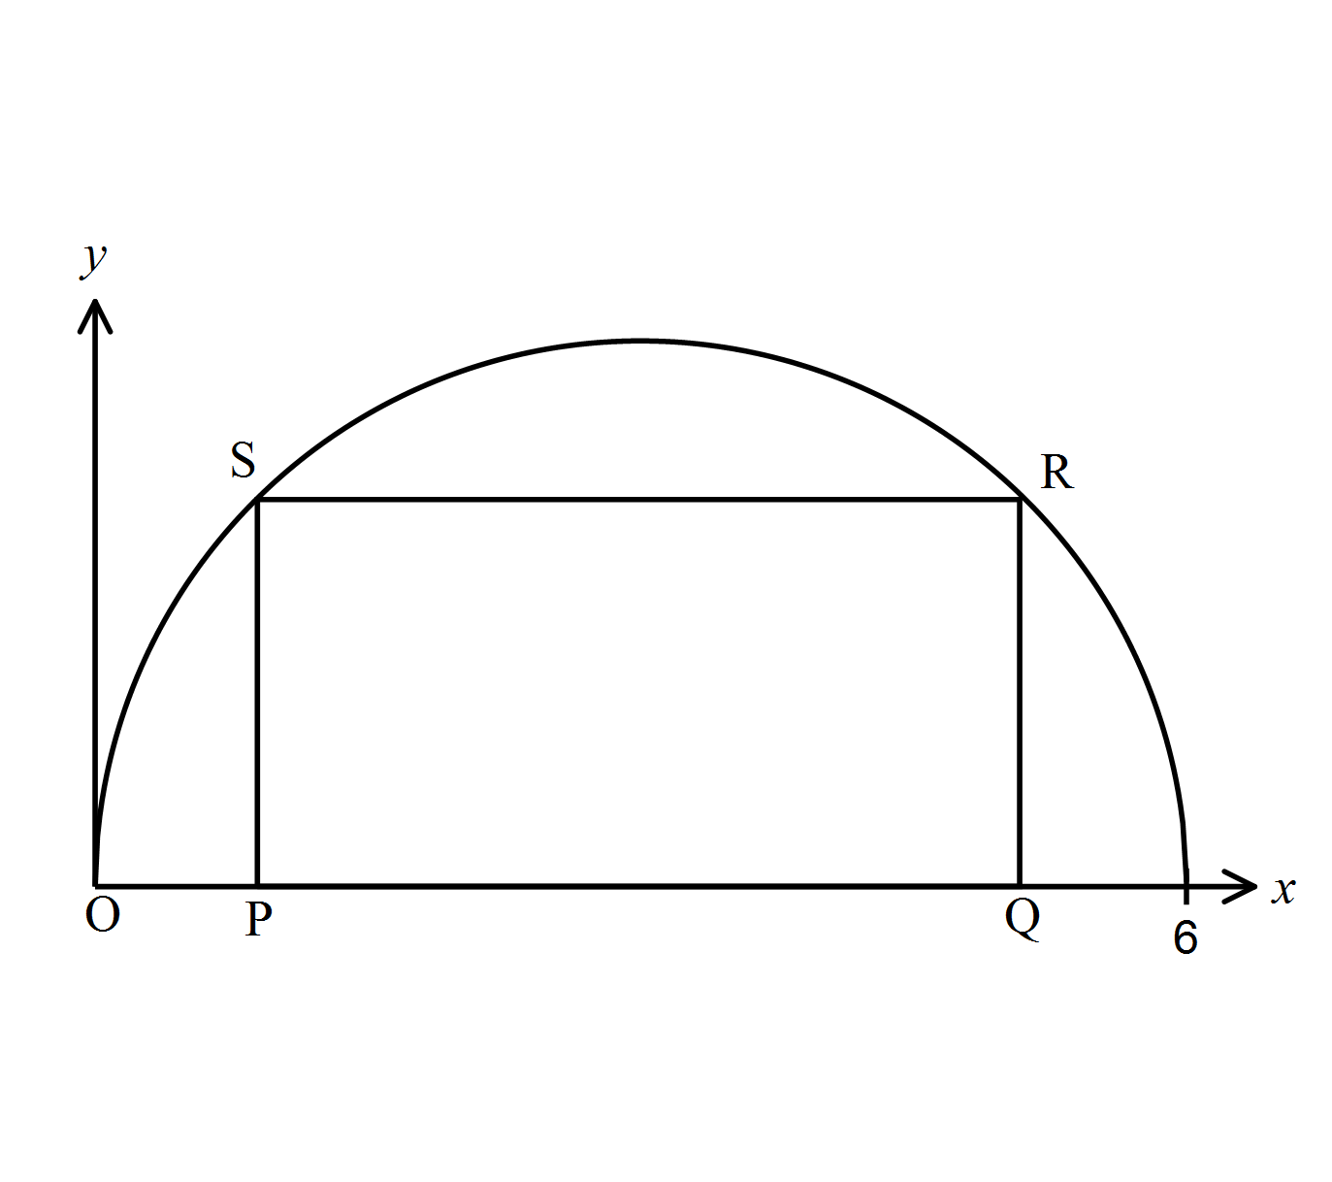

A rectangle PQRS is drawn with upper vertices R and S on the graph of , and PQ on the *x*-axis, as shown in the following diagram.

Let OP = *x*.

(a) Explain why an equation for the area of the rectangle can be written as

 (3 marks)

(b) (i) Find the rate of change of area when *x* = 2. (2 marks)

(ii) The area is decreasing for *a* < *x* < *b*. Find the value of *a* and of *b*. (2 marks)

**Question 7 (8 marks)**

A jet plane travels horizontally along a straight path for one minute, starting at time *t* = 0 , where *t* is measured in seconds. The acceleration, *a* , measured in ms−2, of the jet plane is given by the straight line graph below.

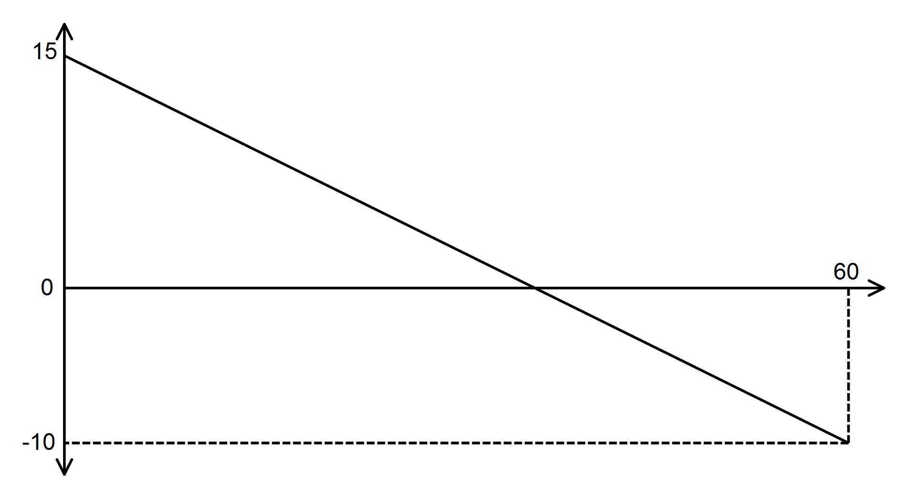

Acceleration *a* (ms-2)

Time *t* (sec)

(a) Find an expression for the acceleration of the jet plane during this time, in terms of *t* . (2 marks)

(b) Given that when *t* = 0 the jet plane is travelling at 125 *ms*−1, find its maximum velocity in *ms*−1 during the minute that follows. (3 marks)

(c) Given that the jet plane breaks the sound barrier at 295 *ms*−1, find out for how long the jet plane is travelling greater than this speed. (3 marks)

**Question 8 (7 marks)**

A rectangular piece of paper measures 12 cm by 6 cm. One corner of the sheet of paper is folded up to just reach the opposite side as shown below.

What is the minimum length of the resulting crease AB in the paper?

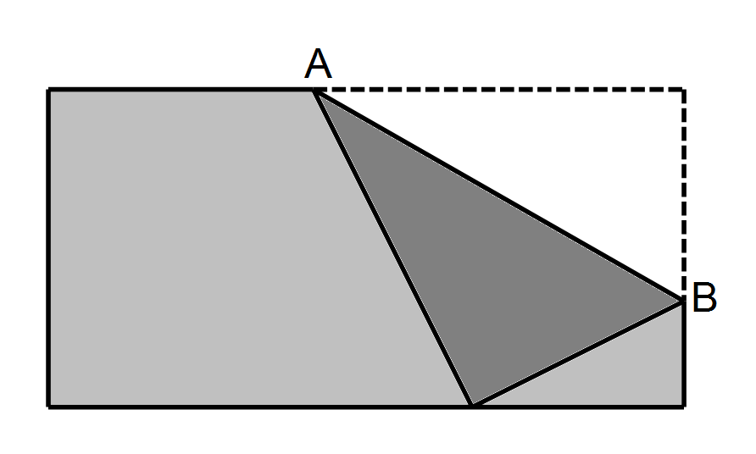

**End of Test**

**or**

**Question 8 (7 marks)**

A closed box is constructed with a square base. Exactly 10 Square metres of material is to be

used in the construction of the box, without wastage.

Let *h* = height of box, *w* = width of box = length of box

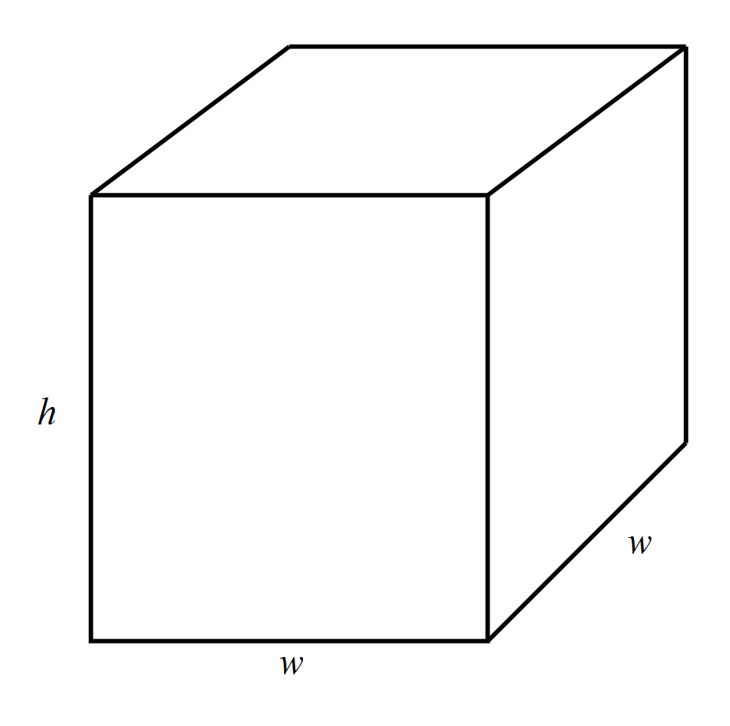

(a) Show that  (2 marks)

(b) By using calculus, determine the maximum volume of the box and state the dimensions

required to acieve this maximum. (5 marks)